SCII/00825/2019
MICHAEL ORINA

ECII 3208: INFORMATION SYSTEMS MANAGEMENT & AUDIT

ASSIGNMENT ONE (30 MARKS)

- Information systems management is an area that pays much attention to aspects such as strategy, leadership and indeed technology. With the aid of suitable illustrative examples, explain the above statement. 8 marks
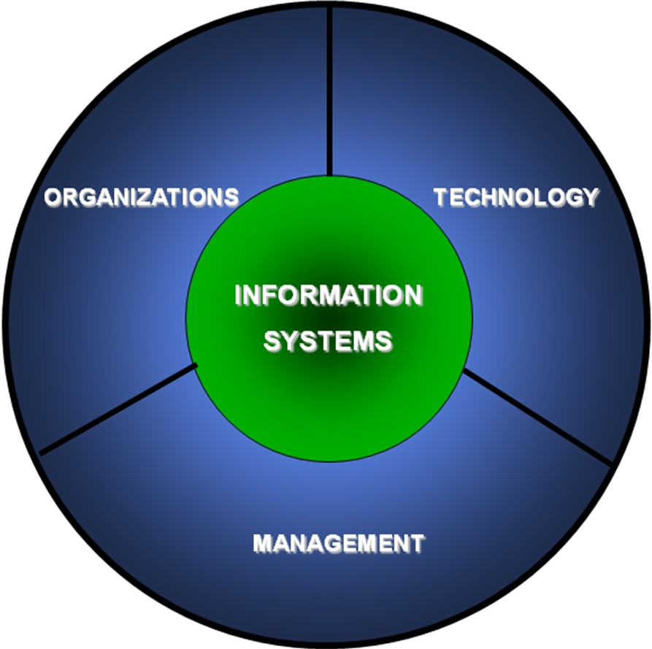

Strategy An information management strategy is an organization's plan to acquire, manage, use, and deliver information through products and services to internal and external customers.

Leadership/Management - IT leadership is the group of senior executives in an organization responsible for the information technology (IT) infrastructure and applications that enable and drive the overarching business strategy and goals.

Technology - Information technology management or IT management is the discipline whereby all of the information technology resources of a firm are managed in accordance with its needs and priorities.

- Discuss the implications of Computer monitoring in an organization. 6 marks

Monitoring workplace computers can secure data stored on computer systems, as well as ensure employees are using workplace computers for business purposes. Some monitoring software comes highly recommended at a reasonable cost and can be customized to an organization's needs.

Ethics and Feelings of Distrust. There are ethical concerns when it comes to employee monitoring, especially as it relates to workplace morale. Employees may feel like you’re violating their privacy or don’t respect or trust them.

Increased Productivity. Monitoring your employees can increase their productivity.

Increased Internal Security and Protection from Harassment. Employee monitoring can have positive impacts on your Cybersecurity and help protect your employees.

- Define ethical quandary. Discuss any six principles that can be used to solve ethical quandaries. 8 marks

It is a dilemma is a problem offering two possibilities, neither of which is unambiguously acceptable or preferable

Know the Principles. In ethical decision making there are three basic principles that can be used for resolution of problem. These three principles are that of intuitionism, moral idealism and utilitarianism.

Debate Moral Choices
Before taking a decision, moral decisions need to be thought upon and not just accepted blindly. It is a good idea to make hypothetical situations, develop case studies and then engage others in brainstorming upon the same.

Balance Sheet Approach. In balance sheet approach, the manager writes down the pros and cons of the decision. This helps arrive at a clear picture of things and by organizing things in a better way.

Engage People Up and Down the Hierarchy
One good practice is to announce ones stand on various ethical issues loudly such that a clear message to every member of the organization and to those who are at the greater risk of falling prey to unethical practices.

Integrating Ethical Decision Making into Strategic Management
Morality and ethical make up for a perennial debate and ethical perfection is almost impossible. A better way to deal with this is to integrate ethical decision making into strategic management of the organization.
Reflect on the outcome of ethical decisions making process. How would you evaluate the consequences of this process for those involved: client(s), professional(s), and agency(ies)?

- Using information systems to beat the competition and increase the value of a product is not easy. It requires changing processes and methods that probably have been in the organization since time began. Highlight a solution guideline to this challenge 8 marks

1. Prepare the Organization for Change
For an organization to successfully pursue and implement change, it must be prepared both logistically and culturally. Before delving into logistics, cultural preparation must first take place.

2. Craft a Vision and Plan for Change
Once the organization is ready to embrace change, managers must develop a thorough and realistic plan for bringing it about.

3. Implement the Changes
After the plan has been created, all that remains is to follow the steps outlined within it to implement the required change.

4. Embed Changes Within Company Culture and Practices
Once the change initiative has been completed, change managers must prevent a reversion to the prior state or status quo.

5. Review Progress and Analyze Results
Conducting analysis and review, or a “project post mortem,” can help business leaders understand whether a change initiative was a success, failure, or mixed result.

ASSIGNMENT TWO (30 MARKS)

- The centralization and decentralization debate continues unabated. Discuss the merits and demerits of both. 10 marks

Centralization. It is the process by which the activities of an organization, particularly those regarding planning and decision-making, framing strategy and policies become concentrated within a particular geographical location group.
Merits
In centralization, upper management, because of its experience, wisdom and broad outlook, is more mature in decision-making. Such decisions carry the chance of being least risky.
The organization can strictly enforce uniformity of procedures and policies.
The organization has a better chance of utilizing the potential of its outstanding employees.

Demerits

Decentralization. In decentralization decision making is left for the lower level of organization.

Merits

Improves the effectivity of managers.
Offers a democratic environment where employees can have a say in their governance.
Provides good exposure to mid and lower-level managers and creates a pool of promotable manpower with managerial skills.

Demerits

In decentralisation, lower level managers, because of their less experience, wisdom and narrow outlook are less mature in decision-making.

- State the latest ways in which technology is used by hotels to provide services to guests and to achieve greater profitability and improved guest satisfaction 6 marks

Hotels now can use smart sensors and hotel apps to allow guests to reserve parking spots in advance of their visit and to have their space assigned upon arrival.

Big Data and Big Data Protection. One of the main benefits of smart technology is how it aggregates data and makes it actionable.
By enabling guests to check in remotely through their mobile device, hotel owners can better predict/manage their staffing needs and save considerably on labor costs.

Mobile Room Keys. Today more and more hotels are offering guests room access via their smartphone app. This is saving costs from printing environmentally harmful plastic key cards

Online Reputation Management Technology. A hotel’s online ratings can not only help predict future bookings, but they offer owners valuable insight into how well a property delivered on guest expectations.

Smart Marketing Practices. Data opportunities of smart technology offer hotels a more complete picture of their guests than ever before.

- A Hotel Management Information System was recently implemented and management would like to measure the system’s success. Suggest six criteria that should be used. 6 marks
System quality – The desirable characteristics of an information system. For example: ease of use, system flexibility, system reliability, and ease of learning
Information quality – The desirable characteristics of the system outputs; that is, management reports and Web pages.
Service quality – The quality of the support that system users receive from the IS department and IT support personnel
Net benefits – The extent to which IS are contributing to the success of individuals, groups, organizations, industries, and nations.
User satisfaction – Users' level of satisfaction with reports, Web sites, and support services.
System use – The degree and manner in which staff and customers utilize the capabilities of an information system.
- Information technology can promote various degrees of organizational change. Explain four kinds of structural organizational change that are enabled by information technology.
Automation which is the use the input of various resources to automate the management of operations and information, creating useful output that can help a company make strategic decisions.
Rationalization is the process of using data to make decisions about how a department or organization buys and uses its technology to become as effective as possible
Re engineering which has the objective of extracting the contents, data structures, and flow of data and process contained within existing legacy systems in order to reconstitute them into a new form for subsequent implementation.
Paradigm shift. A paradigm shift is a major change in how people think and get things done that upends and replaces a prior paradigm

